**Introduction to Algorithms**

**The Role of Algorithms in Computing CH 1 (5-15)**

* Algorithm is a sequence of computational steps that converts an input into output
* Sorting problem:



* Instance of a problem: input that satisfies whatever constraints are specified by the problem
* Things to consider- number of items to be sorted, extent to which items are sorted already, kind of storage device to be used.
* Incorrect algorithms- doesn’t halt at some input instances- may be useful based on **error rate**
* Watch out for NP-complete problems- problems with no apparent solutions
* ***insertion sort***, takes time roughly equal to c1n2 to sort n items, where c1 is a constant that does not depend on n.
* ***merge sort***, takes time roughly equal to c2n lg n, where lg n stands for log2 n and c2 is another constant that also does not depend on n.
  + c1 < c2 , insertion sort runs faster for small sample sizes but since n*log(n) is smaller than n^2 when n = 10^6, merge sort is more efficient for larger values of
* help you get a scope of data to memory usage: an input of 10 million numbers, if they are 8-byte integers, only occupies 80 megabytes
  + given that large amount of data and a super-fast computer A using insertion sort, and a mediocre computer B using merge sort, Computer B proves faster:



* Using an algorithm whose runtime grows slowly with input data size proves more efficient in this sort of scenario

**Getting Started CH 2 (16-42)**

* Sorting problem introduced in previous outline solved using insertion sort



* Loop invariant helps us understand why an algorithm is correct.
  + **Initialization:** It is true prior to the first iteration of the loop.
  + **Maintenance:** If it is true before an iteration of the loop, it remains true before the next iteration.
  + **Termination:** When the loop terminates, the invariant gives us a useful property that helps show that the algorithm is correct.
* Initialization: when j = 2, key = A[2] (key is a place holder), i = 1, i > 0 and A[i/1] > A[2] (checks if first element is bigger than second element) so A[(i+1) or (2)] = A[i/1] (sets second element to first element, if first element is bigger than second element), i = 0, breaks out of while loop, A[1] set to A[key] (if while loop does not run than A[2] is set to key which is A[2] from the start meaning nothing happens)
  + Book explanation:

**

* Maintenance: The initialization step is repeated as J increases but i reduces to 0 as it iterates to check if A[i] is bigger than *key* each time as i decreases.
  + Book explanation:



* Termination: loop terminates when j > A.length or j > n, and the list should be sorted now, as key was repeatedly used to replace A[j] throughout the code.
* Time taken by an algorithm dependent on input size and running time
* Running time of insertion sort:

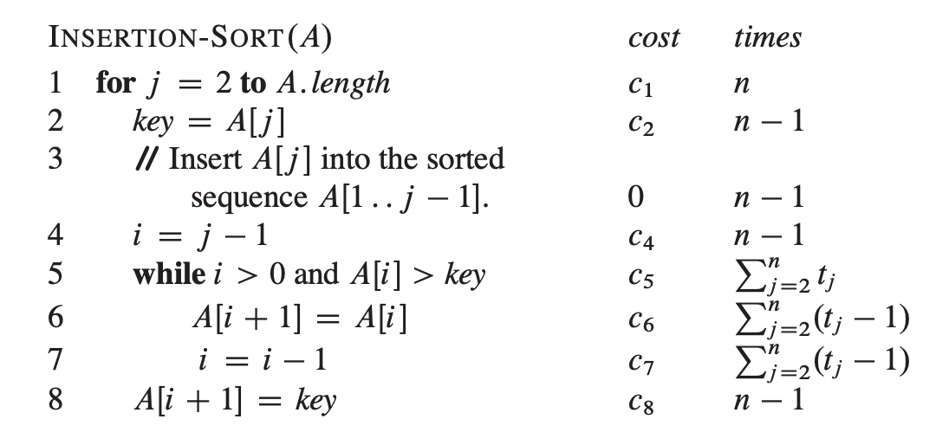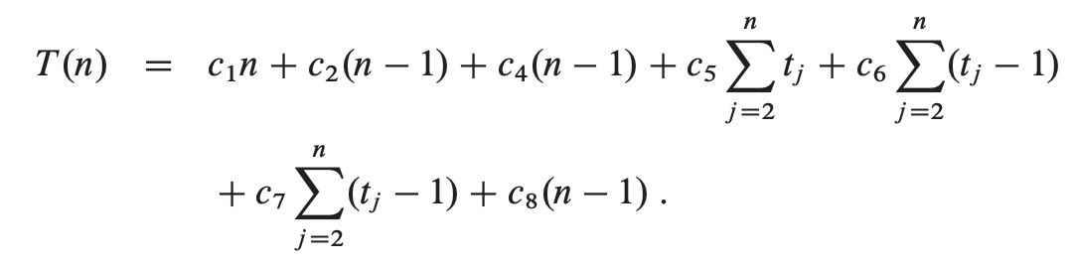

* When already sorted the best-case running-time is:

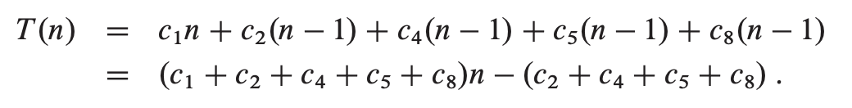

* In the worst-case scenario (array is in reverse order)

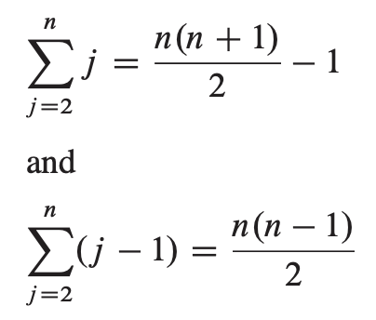: 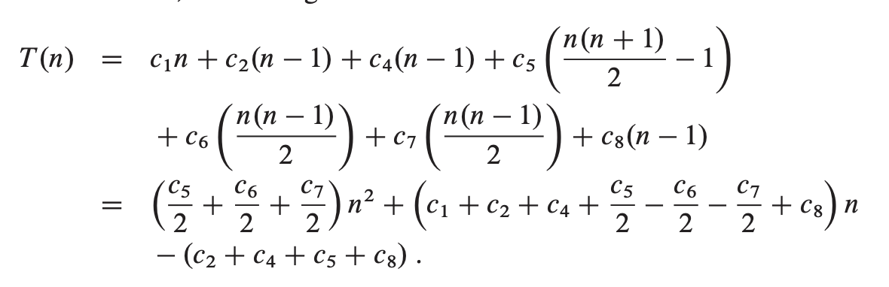

* Best case running time is: *an+b* while worst case running time is *an^2 + bn + c*
* Worst case running time gives an upper bound on the running time for any input
  + Searches for absent information often occurs causing worst-case scenario
* From *an^2 + bn + c,* we only consider the first term and we ignore the coefficient
  + For insertion sort, the worst-case running time is theta-of-n^2
* An algorithm is more efficient than another algorithm if its worst case running time has a lower order of growth.
* The divide-and-conquer approach:

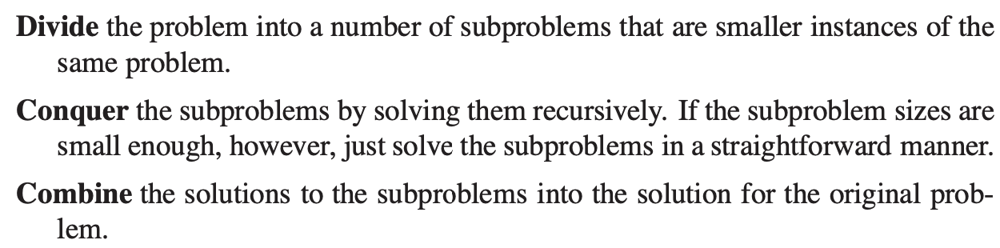

* + Useful algorithms are recursive in structure
  + Merge sort:
    - **Divide:** Divide the n-element sequence to be sorted into two subsequences of n/2 elements each.
    - **Conquer:** Sort the two subsequences recursively using merge sort.
    - **Combine:** Merge the two sorted subsequences to produce the sorted answer.
* Procedure Merge(A,p,q,r) has p <= q < r and assumes that A[p…q] and A[q+1…r] are in sorted order. This has a running time of theta-of-n where n = r – p + 1.
* Infinity sign = sentinel value = cannot be the smaller card unless both indices have the sentinel value.

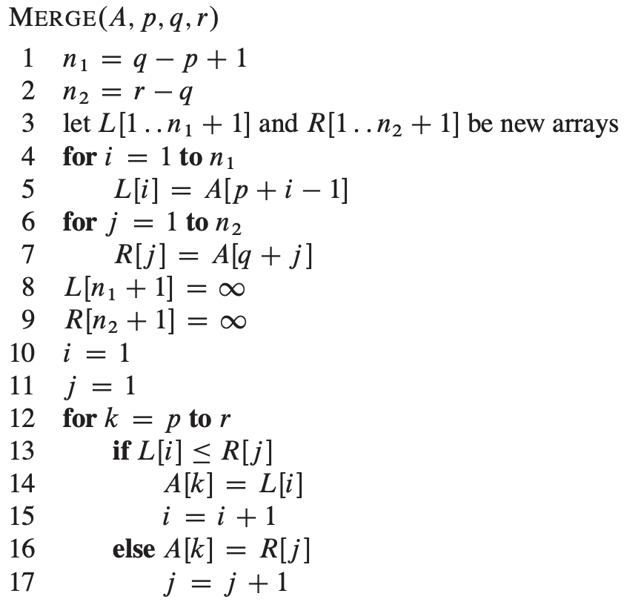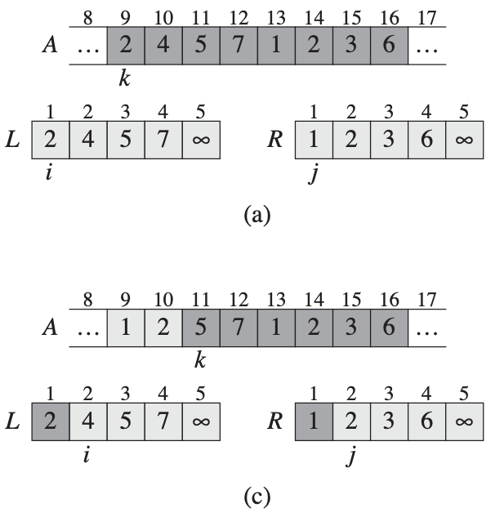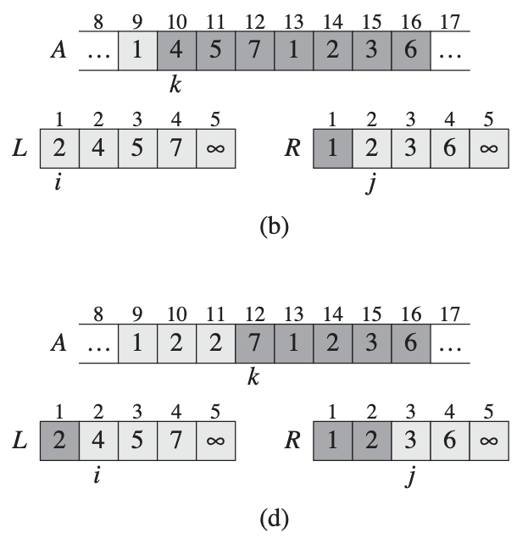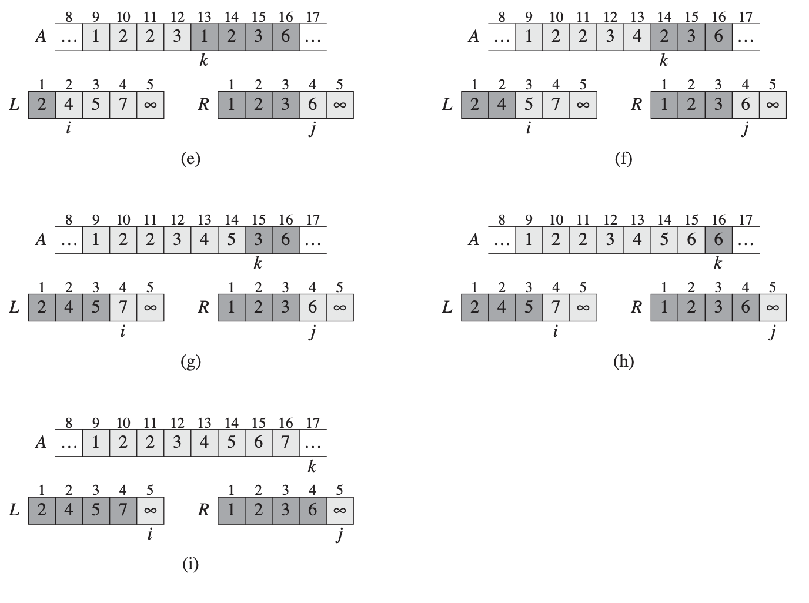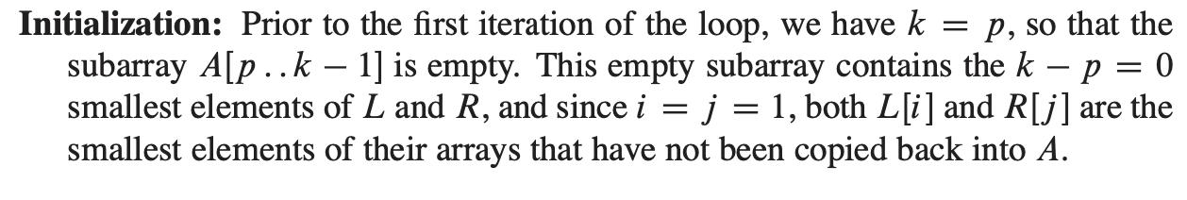

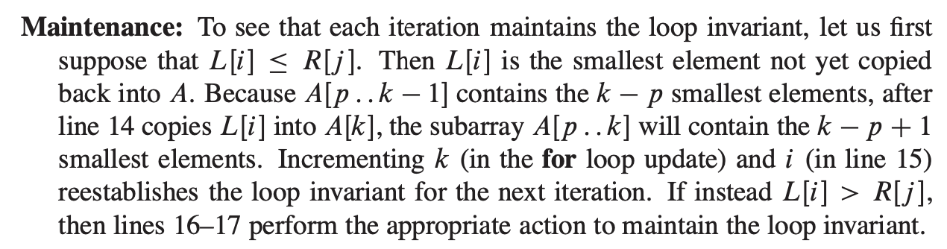

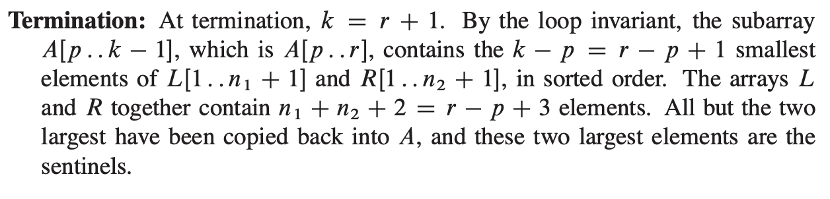

* Divide and conquer algorithms: 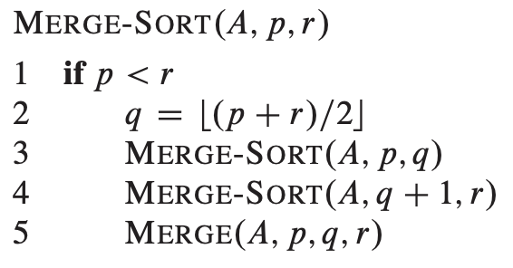
  + Running time of an algorithm containing recursion is described using recurrence equation **\*\*\* require more reading \*\*\***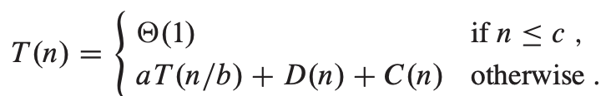

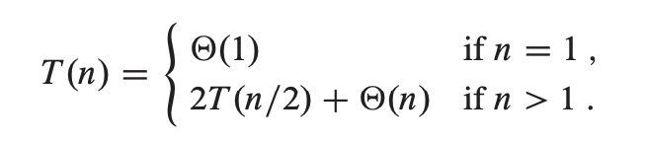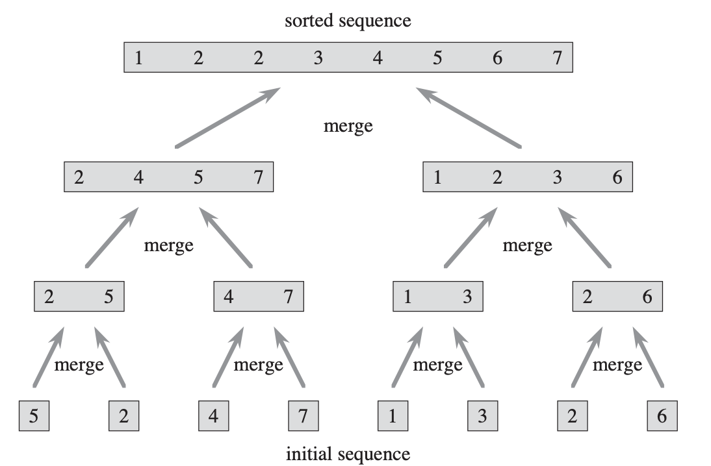

* ^ Suppose that our division of the problem yields *a* subproblems, each of which is *1/b* the size of the original

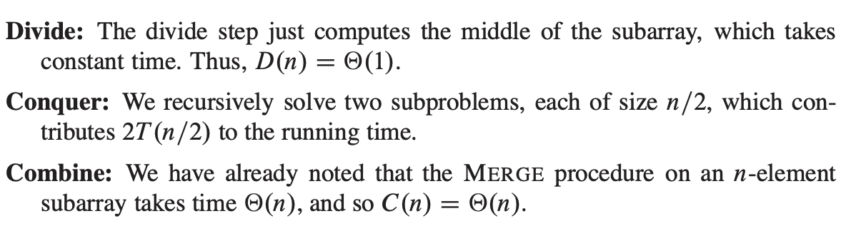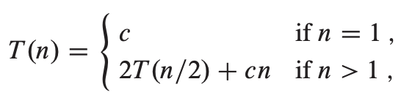

**Growth of Functions CH 3 (43-60)**

* Asymptotic efficiency: how the running time of an algorithm increases with respect to an indefinite increase of the input size
* for a given g(n), theta of g(n) is denoted the set of functions.
* O-notation used for upper bound on function
  + Used to bound the worst-case running time of an algorithm
* Theta of g(n) refers to asymptotically tight bound for f(n) is for a certain interval of n, the function f(n) is equal to the function g(n) within a constant factor.
* Omega-notation refers to asymptotic lower bound – at least how long an algorithm would take to run given a particular input size (n).
* 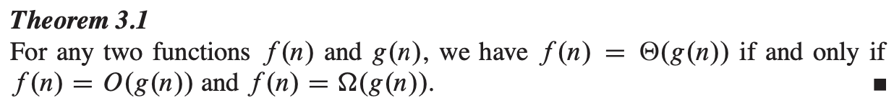
* o- notation used to denote an upper bound that is not asymptotically tight.

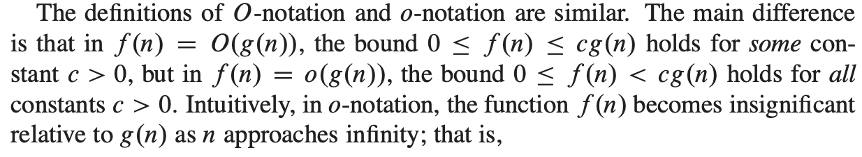

* w- notation: (small omega notation) is the same as above but for the lower bound

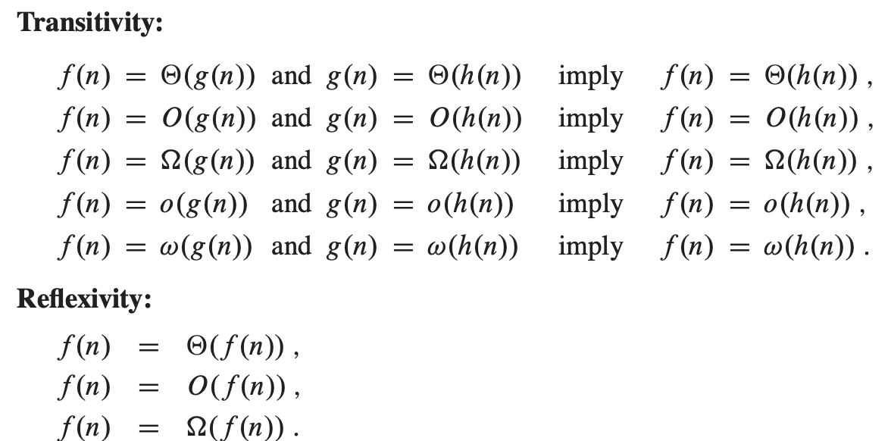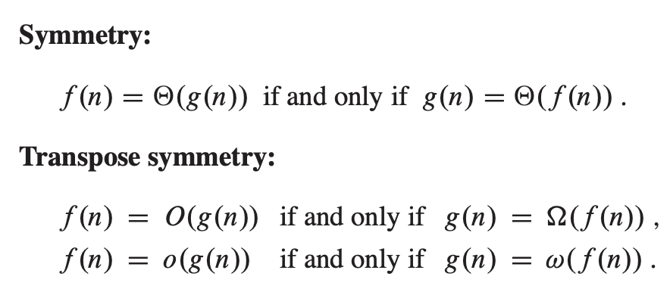

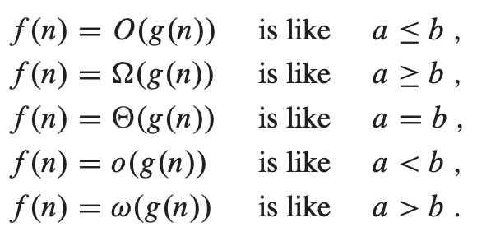



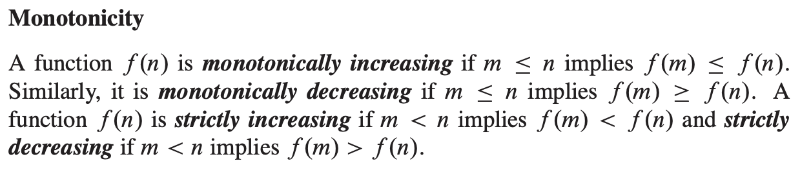

**Divide-and-Conquer CH4 (65-106)**

* When the subproblems are large enough to solve recursively, we call that the ***recur- sive case***. Once the subproblems become small enough that we no longer recurse, we say that the recursion “bottoms out” and that we have gotten down to the ***base case***.
* 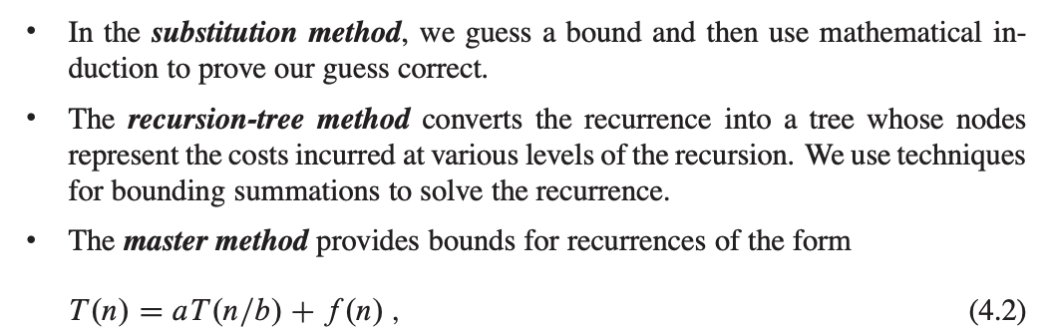

**The substitution method for solving recurrences:  
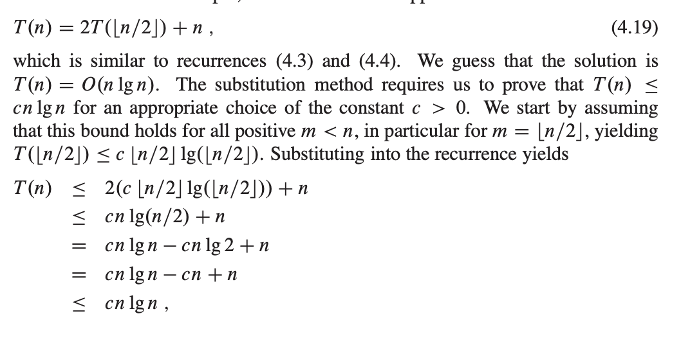**

**Recurrence tree:  
